CURRICULAM VITAE

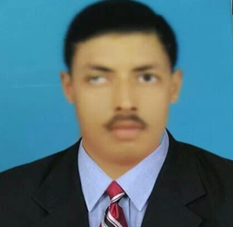
RAMAN JEE JHA
B- 8/2 Sainik Nagar, Uttam Nagar, Delhi (110059)
Cell: 09999796472, Email: ramanjeejha1900@gmail.com

5+ years of work experience in the field of IT & finance

Objective:

To get an exposure in the areas of IT & finance with an organization which motivate
to achieve personal as well as organization goals.

WORK EXPERIENCE

- Softage information technology Ltd. – (www.softageindia.com)

- JOB PROFILE
Softage Information technology Ltd. – Data auditor & data processing
3rd Oct 2009 to 1st Jan 2015.

- Data Audit and Processing –To Document collection , Document verification Image Processing , Data Processing ,data storage Data Search & Retrieval

acadmic quilification

- Graduation B.COM. from L.N.M.University Darbhanga.
- Intermediate from BSEB Patna. (commerce)
- Schooling from BSEB Patna.

Computer Knowledge:

- Tally & Proficient in computer fundamentals. Such as Ms Office, Windows, etc.

ACHIEVMENT

- Won 1st Prize in Co large competition.(District Level)
- First prize achiever in cycle racing in schooling time
- Participated in many Seminars, presentations and exhibitions

Strengths:

- Self confidence with convincing attitude

Personal information:

Date of Birth 20th October1988
Gender Male
Marital Status Unmarried
Language English, Hindi.

(Raman jee Jha)

Date-
Place- Delhi

